

**College of Professional Studies**

**Northeastern University San Jose**

**MPS Analytics**

**Course: ALY6020 – FINAL PROJECT**

**THREADS APP SENTIMENT ANALYSIS**

**Submitted on:**

Oct 27th, 2023

**Submitted to:**  **Submitted by:**

Professor: BEHZAD AHMADI BHAGYASHRI KADAM

**INTRODUCTION**

The Threads App Reviews Dataset is a robust compilation of user feedback and ratings sourced from both the Google Play Store and the App Store, centering around the Threads mobile app. By merging reviews from two of the largest app marketplaces, this dataset paints a comprehensive portrait of user sentiment, capturing the highs and lows of their experiences. It serves as a pivotal resource in gauging overall user satisfaction, pinpointing areas of the app’s performance that resonate well, and highlighting those that might require attention. The user sentiments and ratings can help developers and stakeholders of the Threads app to harness this data to strategize future updates, optimize user experience, and enhance overall app functionality.

**Understanding the Dataset**

The given dataset encompasses a total of **32,910 records and 4 distinct columns/attributes,** each signifying a unique aspect of user reviews for the Threads mobile application. These columns shed light on attributes such as the "source", detailing from which platform (like the Google Play Store or App Store) the review was curated. The "review_description" offers firsthand user feedback about the app's features, performance, and overall experience. We also have the "rating" column, which provides a numeric score assigned by the user, giving a quantifiable measure of their satisfaction. Lastly, "review_date" captures the exact timestamp of when the review was submitted, offering a chronological perspective on user feedback. This dataset is instrumental in comprehending user sentiments and feedback patterns, guiding future app enhancements and marketing strategies. Below are the datatypes of the attributes:

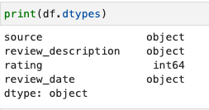

**PART 1 : DATA CLEANING**

* **Checking the number of missing values for each Attribute in the dataset**

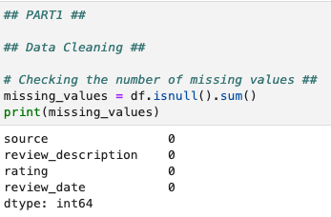

From the above output, we can observe that there no missing values in the dataset,

**Dropping duplicates :**

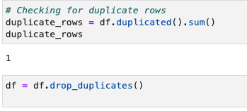

**Modifying the datatype of review_date column and checking the min and max dates :**

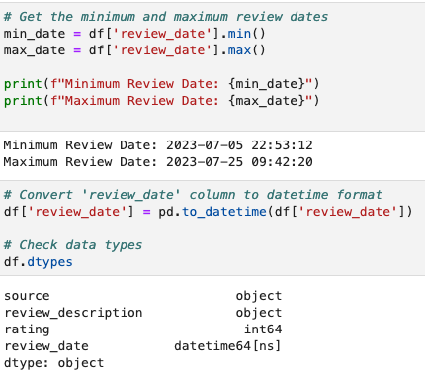

**Feature Engineering:**

Separating the data & time from the review_date column and then dropping the original review_date colum as below:

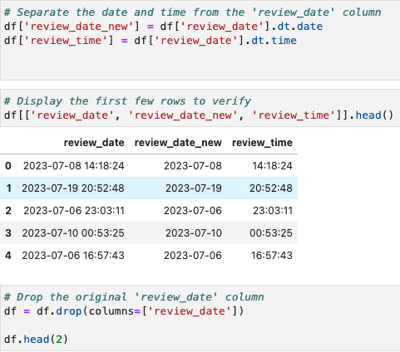

**Creating a new column – day as below for analysis:**

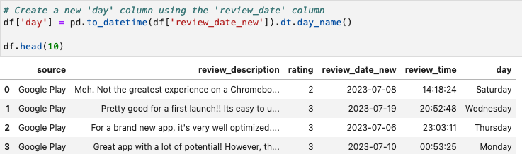

**Creating a new column – hour as below :**

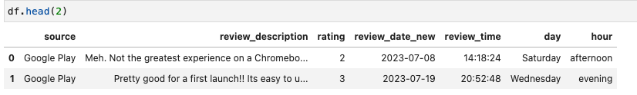

**PART 2: EDA**

**Daily reviews by source :**

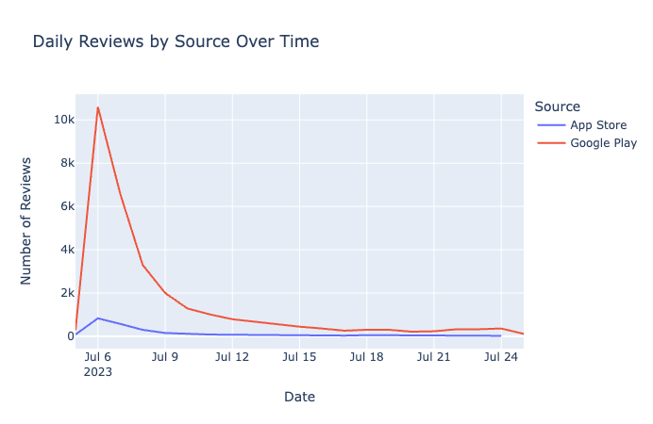

The above graph represents the number of daily reviews from two sources: the App Store and Google Play over a period from July 6, 2023, to July 24, 2023 and below are some key insights :

* There is a significant spike in the number of reviews from Google Play around July 6-7, reaching close to 10,000 reviews on a single day.
* After the initial spike, the number of reviews from Google Play sharply decreases, stabilizing to a much lower number by mid-July.
* Reviews from the App Store remain relatively stable and low throughout the entire period.

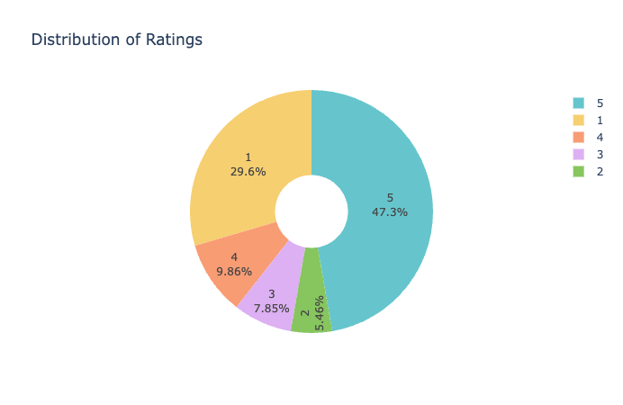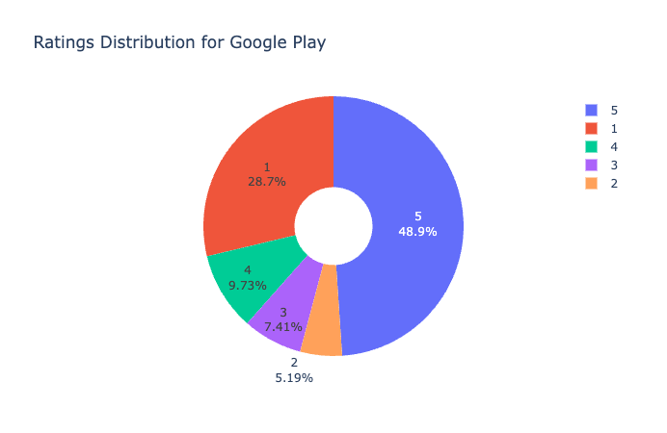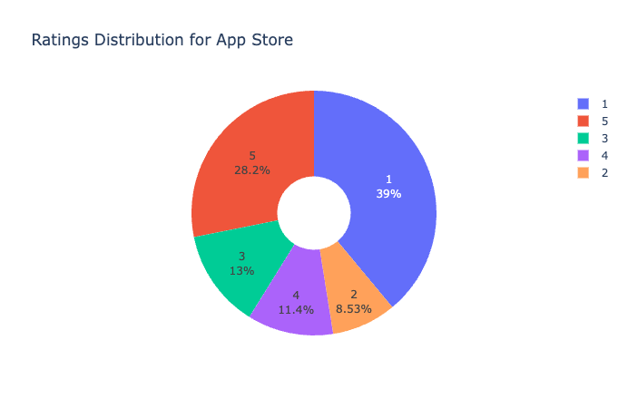

The above donut charts depict the overall ratings and the ratings across google play store and app store and below are some key observations :

* The highest rating (5 stars) is the most common across all distributions, with Google Play users slightly more likely to rate the app with 5 stars compared to App Store users.
* There's a significant polarization in feedback, with high numbers of both 5-star and 1-star ratings. This indicates that users either really like the app or have significant issues with it.
* Users on the App Store seem to be more critical, with a higher percentage giving the app a 1-star rating compared to Google Play users.

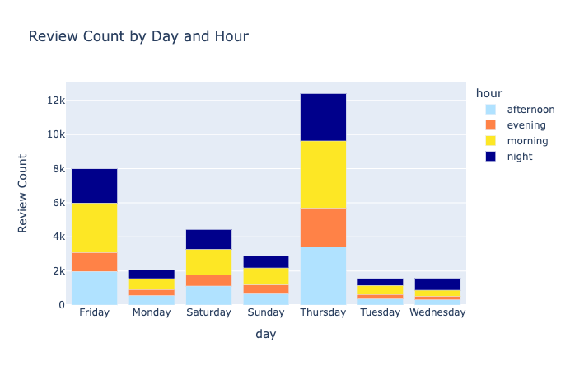

The stacked bar chart provided shows the distribution of review counts based on the day of the week and the time of day (segmented into morning, afternoon, evening, and night). Here are some observations from the chart:

* Thursday Peaks : Thursday morning sees the highest activity with 3934 reviews followed by Thursday afternoon which is 3402.
* Additionally, there were 1970 reviews on Friday afternoon and 2903 reviews on morning indicating peak in user activity
* Mornings seem to have a more consistent review pattern across the days, which might indicate regular users who engage with the app as part of their morning routine.
* The lowest number of reviews is on Wednesday evening, with 215 reviews.

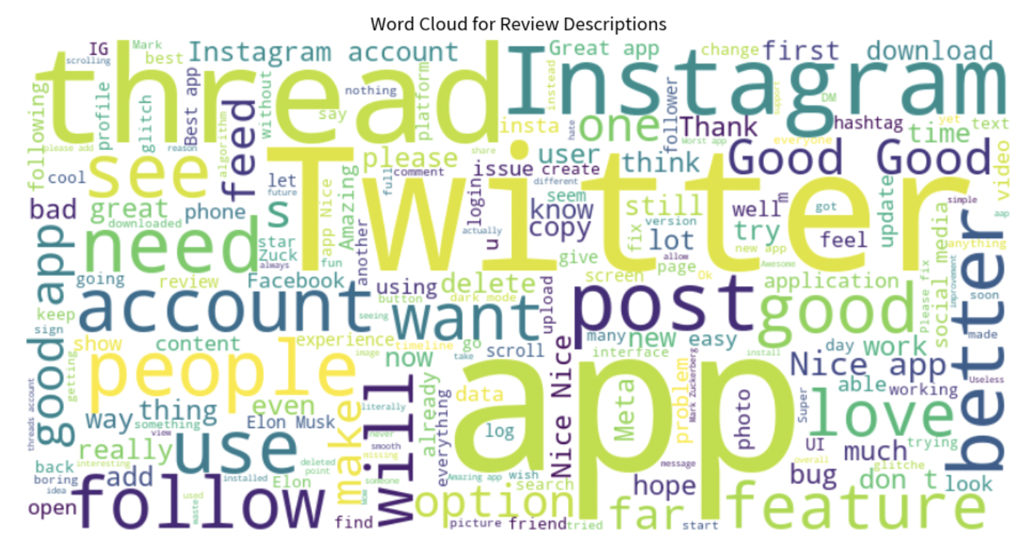 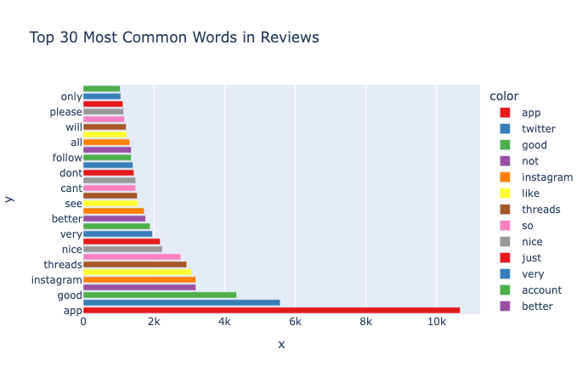

* Words like "Instagram", "Twitter", "post", "account", "follow", and "feature" are prominently displayed, indicating that these are frequently mentioned topics.
* Also Positive words such as "good", "love", "nice", "best", and "great" suggest a generally favorable opinion of users towards the app or feature under review.
* The most frequently mentioned word is **"app"**, followed by words related to social media platforms, like **"twitter"** and **"instagram"**.

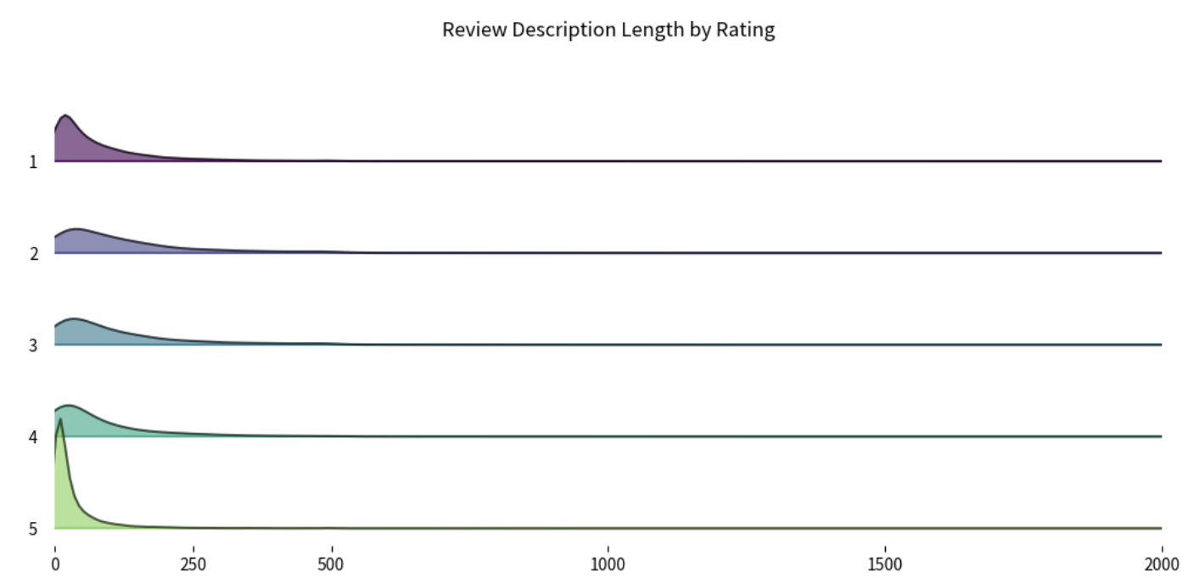

The above ridge chart shows the distribution of review description lengths categorized by the ratings (1 through 5) and below are some observations :

* Most reviews across all ratings tend to be shorter length below 250 chars
* Reviews rated 1 have shorter descriptions. Ratings 2 have a similar trend but the descriptions looks slightly longer on average.
* For Ratings 3 & 4, the review lengths look evenly distributed
* Reviews with rating 5 , we can see a peak indicating the most descriptions concentrated at the lower end. under 250 chars.

**PART 3 : TEXT PRE-PROCESSING**

**Clubbing Ratings:**

Before proceeding with text pre-processing, we need to club or combine the ratings as below:

* Ratings of 1 and 2 are clubbed together and mapped to -1, which can be interpreted as negative feedback.
* A rating of 3 remains neutral and is mapped to 0.
* Ratings of 4 and 5 are clubbed together and mapped to 1, indicating positive feedback

This is done to simplify the analysis by reducing granularity. By grouping ratings, one can focus on the broader sentiment (negative, neutral, positive) rather than specific rating values.

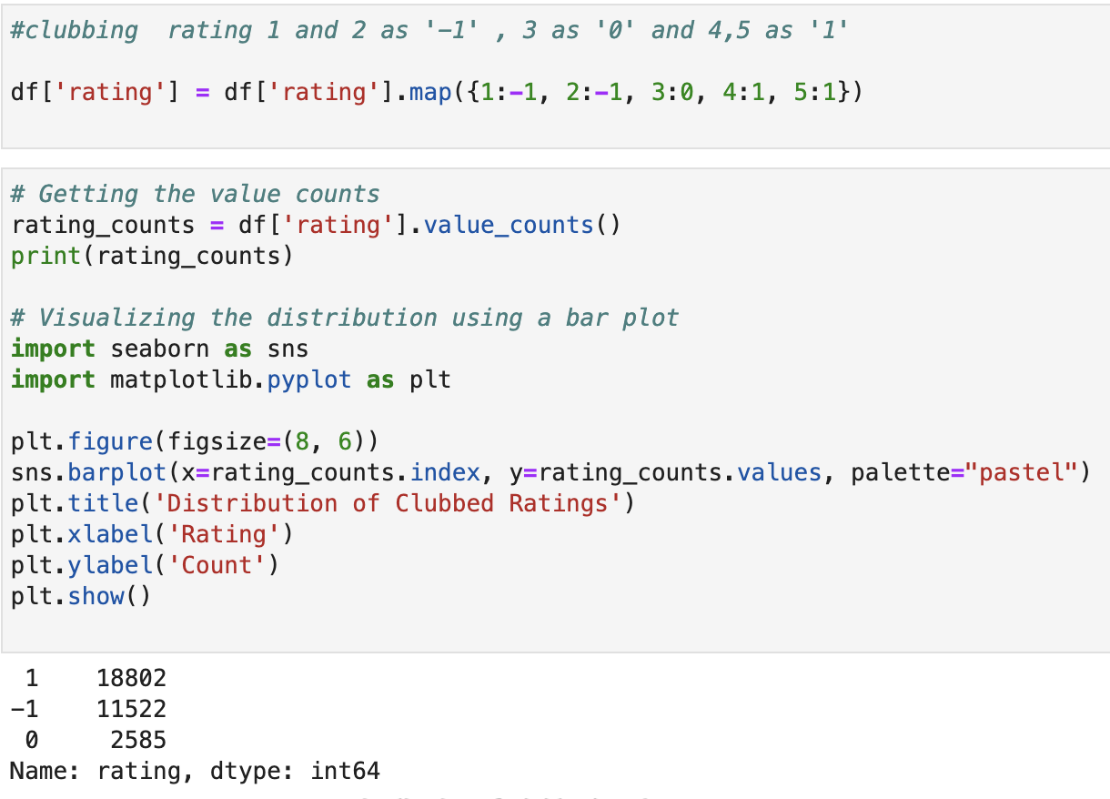

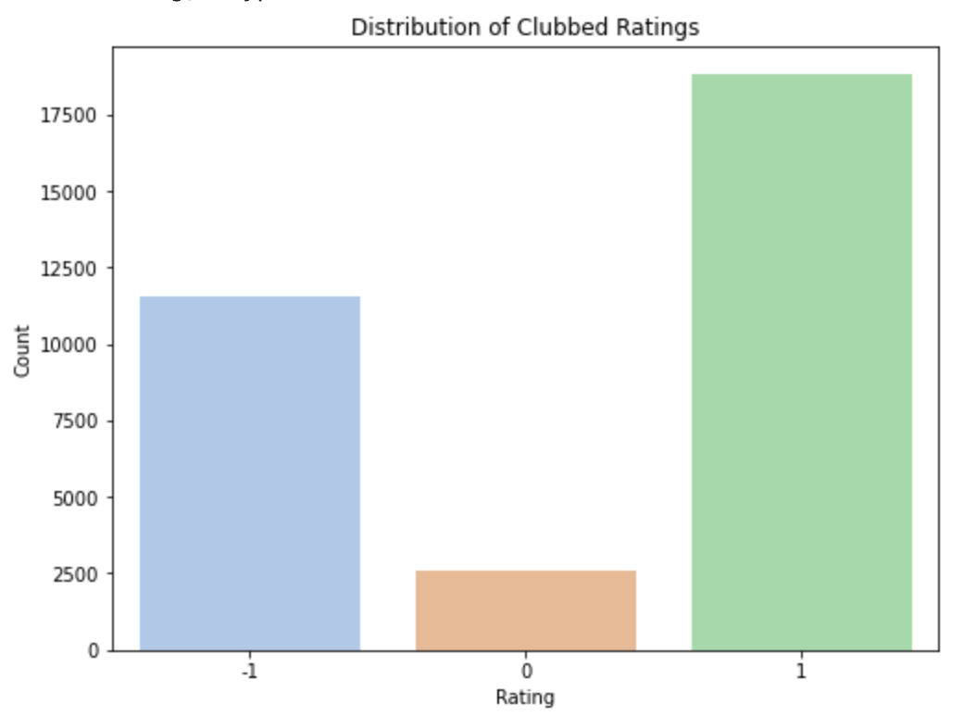

From the above barplot , we can see that after clubbing the ratings , majority of reviews in the dataset are positive, followed by negative reviews. Neutral reviews constitute the smallest portion.

Further , **text pre-processing** is an essential step in many Natural Language Processing (NLP) and text analytics tasks. Raw text data usually contains a lot of noise and irrelevant information. Cleaning and transforming this data into a more digestible form improves the performance of subsequent analytics or machine learning models.

I have taken the below steps to handle the raw data in our reviews description :

Using the required library 're' for regular expression operations is imported and list of common 'stopwords' (words like 'and', 'the', 'is', etc.) is defined. These words are often removed during text processing to focus on meaningful words.

A function preprocess_text_simple is defined to clean and preprocess the text.

Inside this function:

* The text is converted to lowercase.
* URLs are removed using regular expressions.
* Emojis are removed by converting text to ASCII and decoding it.
* Punctuation marks are stripped off.
* The text is tokenized into individual words.
* Words that are in the stopwords list are removed.
* The cleaned and processed words are joined back and returned.

This preprocessing function is applied to each entry in the 'review_description' column of the DataFrame 'df', creating a new column 'processed_description' with the cleaned and pre-processed text.

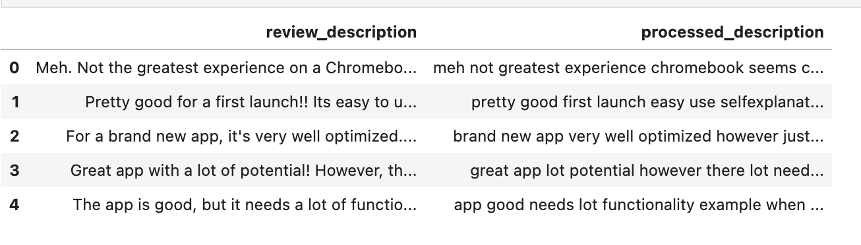

From the processed description, I have further plotted the Top 20 frequent words in reviews

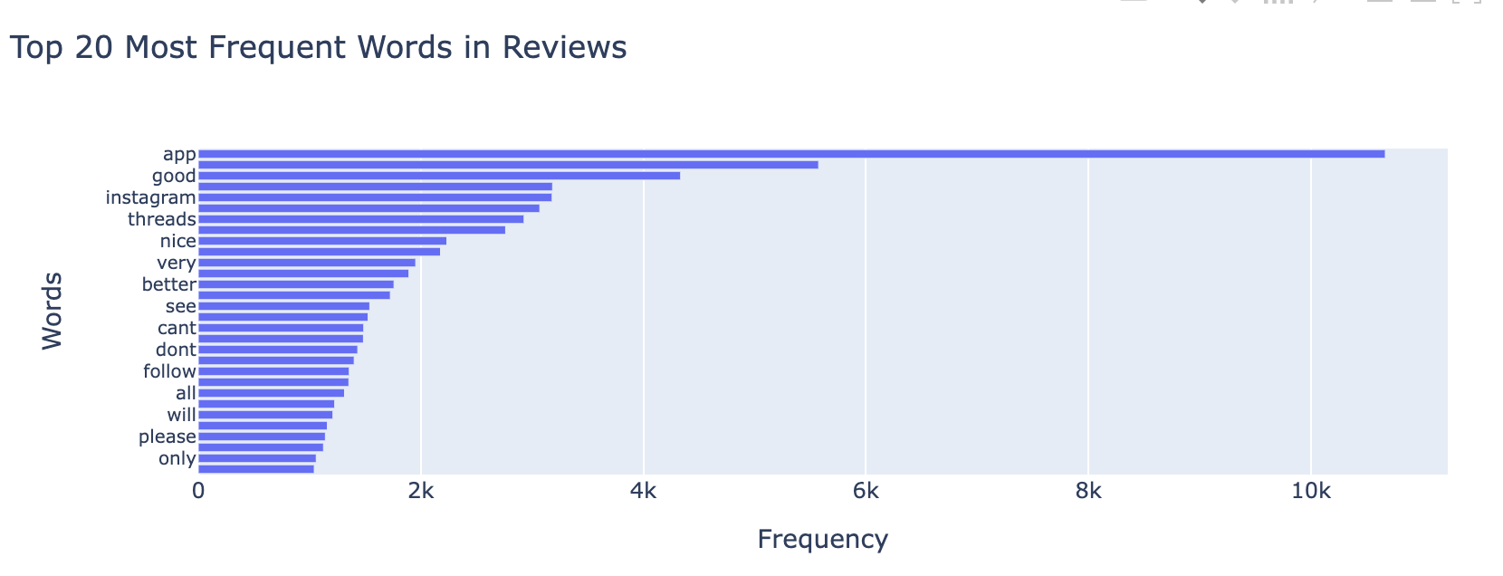

* From the above horizontal barplot , we can observe that the word "app" stands out with the highest frequency. Also Words such as "good," "nice," and "better" indicate that there are positive sentiments expressed in many reviews.
* The presence of "instagram" suggests that the reviews might be related to Instagram comparison
* Words like "see," "can't," "don't," "follow," and "please" may hint at user feedback regarding certain functionalities or features.

Further , I have also plotted the Bigrams and Trigrams to understand the most frequent two-word and three-word combinations used in a set of reviews :

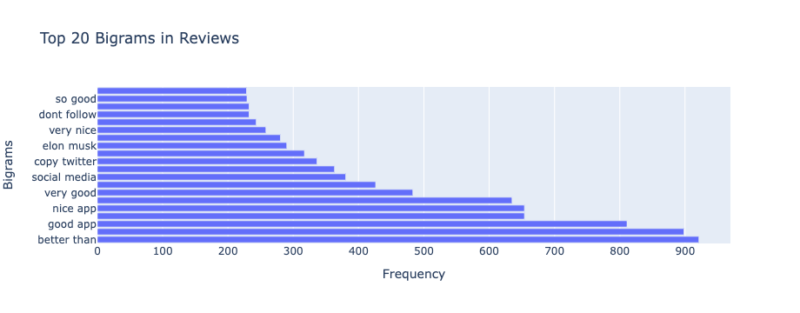

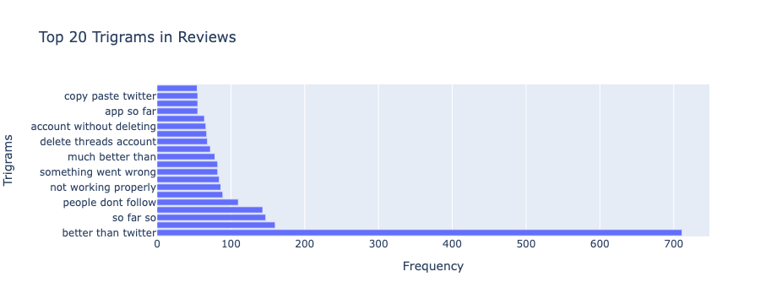

* Positive feedback: Phrases like "so good," "very nice," "very good," "good app," and "nice app" appear to be quite frequent, suggesting that there is positive feedback
* Comparison with twitter: Bigrams like "copy twitter" and "better than" and trigrams like "copy paste twitter," "much better than," and "better than twitter" strongly indicate comparison with Twitter

**Further , I have analyzed the most frequent words used for each of the Ratings (-1,0 and 1)**

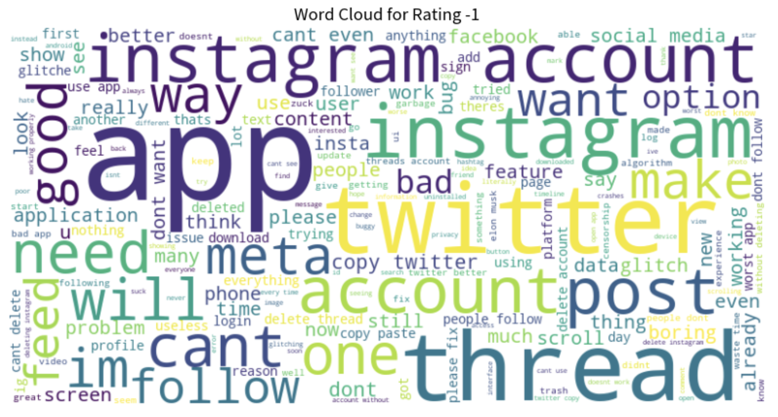

* Word size in the matrix indicated frequency (larger words = higher occurrence).
* Most prominent words for Rating -1 are Instagram, Twitter, account , app , thread , want & post.
* Negative words like "bad", "glitch", "problem", "delete", "issue", "boring", and "cant" (can't) suggest that many users have had unsatisfactory experiences with the app or platform.
* Also , the presence of the words "Instagram" and "Twitter" in close prominence might indicate comparisons between the reviewed application and these platforms

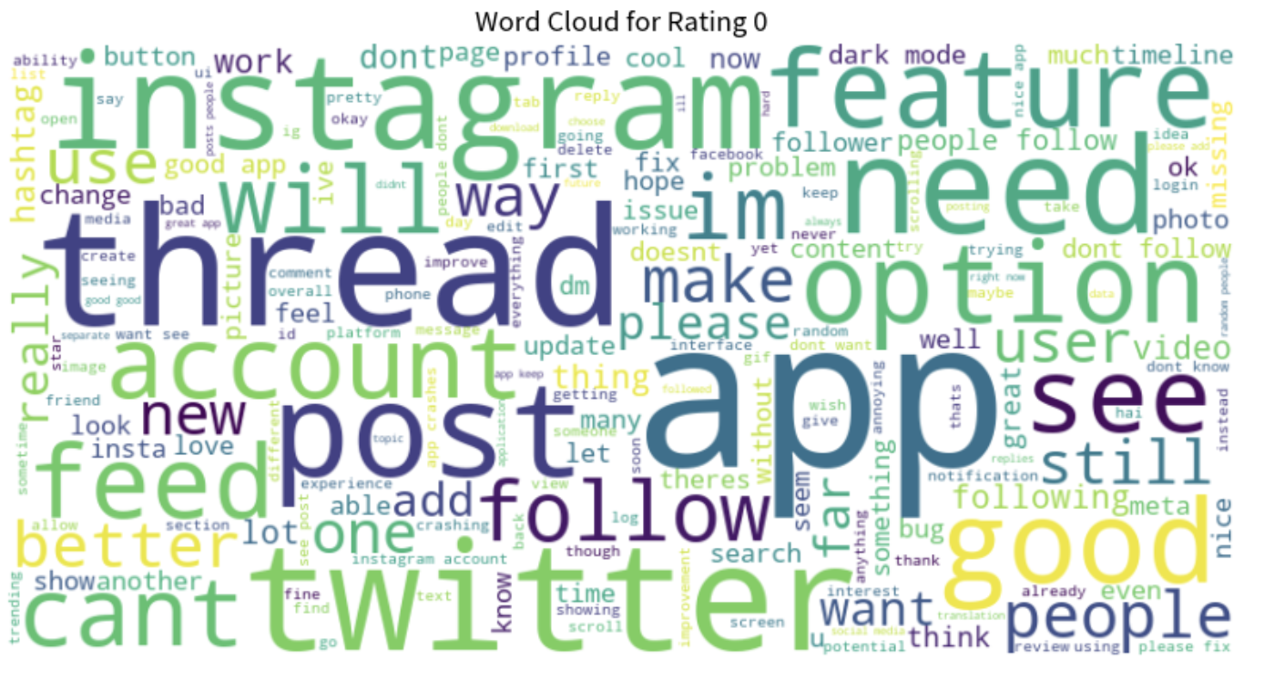

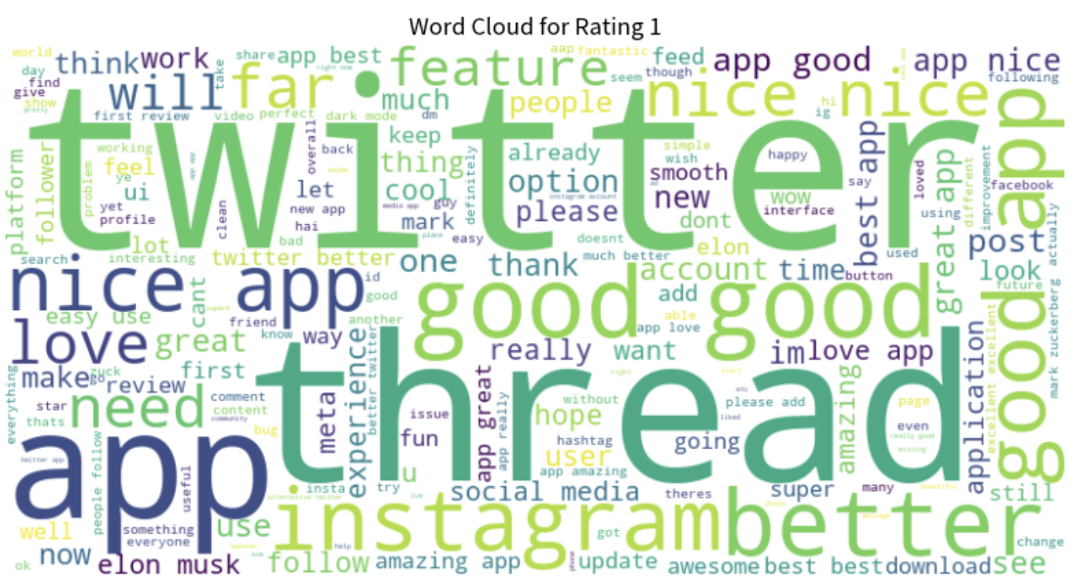

* For Rating 0 - A mix of both positive ("good", "love", "like", "better", "nice") and negative words ("bad", "problem", "issue", "bug", "cant" [can't]) hint at a balanced view, reflective of the neutral rating.
* For Rating 1 - Predominantly positive sentiments can be observed with words like "love", "great", "good", "nice", "best", "amazing", "happy", "cool", and "wow".

**TF-IDF Vectorization:**

* **TF-IDF** stands for **Term Frequency-Inverse Document Frequency**. It is a method to quantify a word in documents, which helps in understanding the importance of the word across various documents. Words that are unique to a particular document will have higher TF-IDF scores.
* I have imported the TfidfVectorizer from the scikit-learn library, which will be used to compute the TF-IDF scores of words.
* The vectorizer is fit to the 'processed_description' column of the dataframe df, and it transforms the text data into a matrix of TF-IDF values.
* I have then extracted the feature names and their corresponding scores
* Lastly , I have visualized the top 20 words based on their TF-IDF scores. Common English words are ignored, and words appearing in more than 85% of the documents are excluded. The result is a bar plot showing the importance of each word across the provided documents.

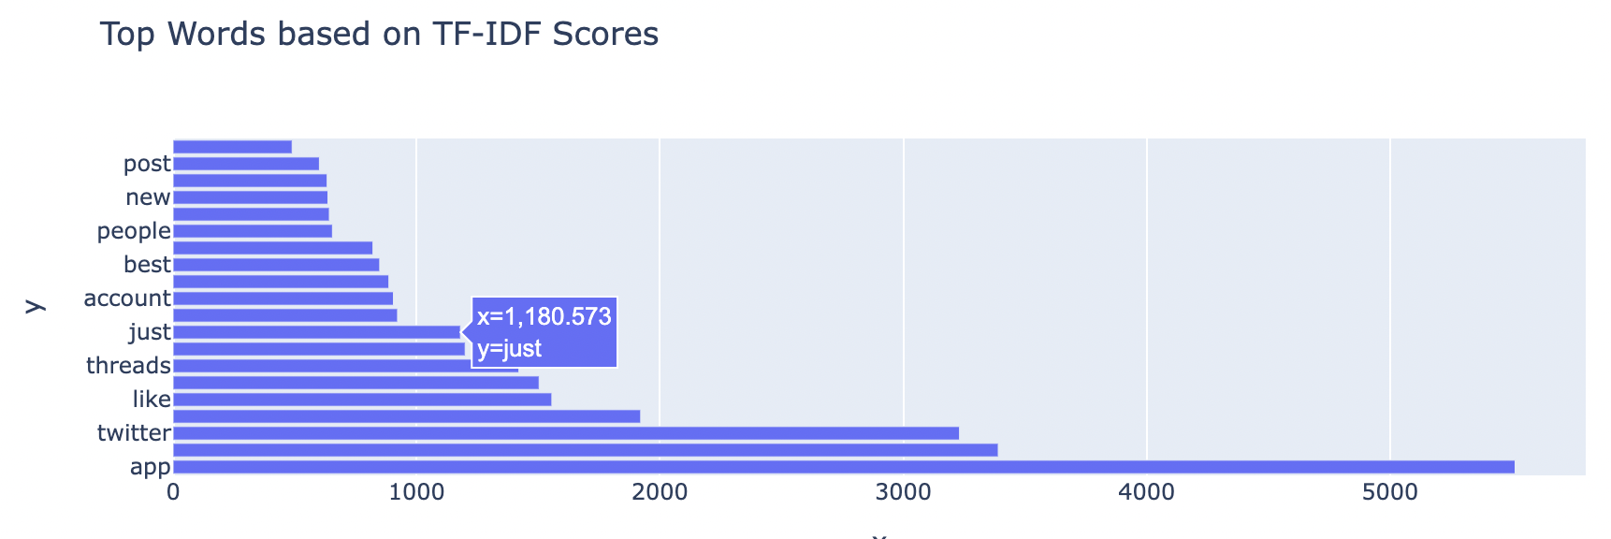

The terms that appear to have the highest TF-IDF scores, in descending order, are "post", "new", "people", "best", "account", "just", "threads", "like", "twitter", and "app".

**PART 4 : MODEL BUILDING**

**Random Forest Model :**

* Random forest model is built using a Random Forest classifier model to predict 'ratings' based on 'review_description' from a dataset.
* The dataset is split into features (X) represented by the 'review_description' column and the target variable (y) represented by the 'rating' column.
* The TfidfVectorizer from sklearn is used to convert the text data in 'review_description' into a numerical representation using the Term Frequency-Inverse Document Frequency (TF-IDF) technique.
* The TF-IDF vectorization is set to consider a maximum of 5,000 features (words) and to ignore common English stop words.
* The dataset is split into training and testing sets, with 80% of the data used for training and 20% reserved for testing.
* The RandomForestClassifier from sklearn is initialized with 100 decision trees (n_estimators). The classifier is then trained using the training data and predictions are made on the test data.

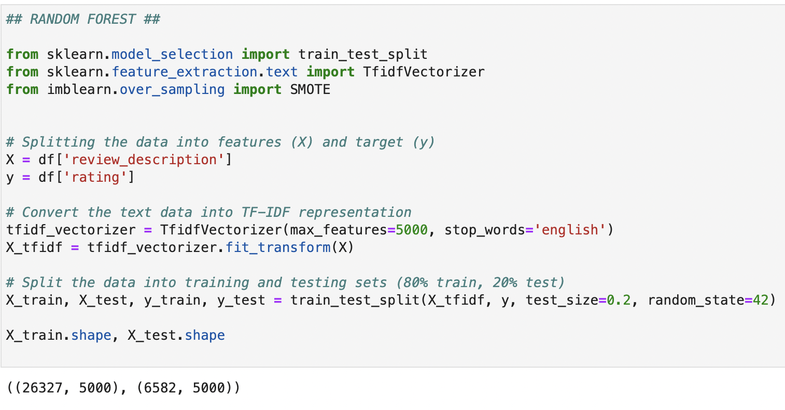

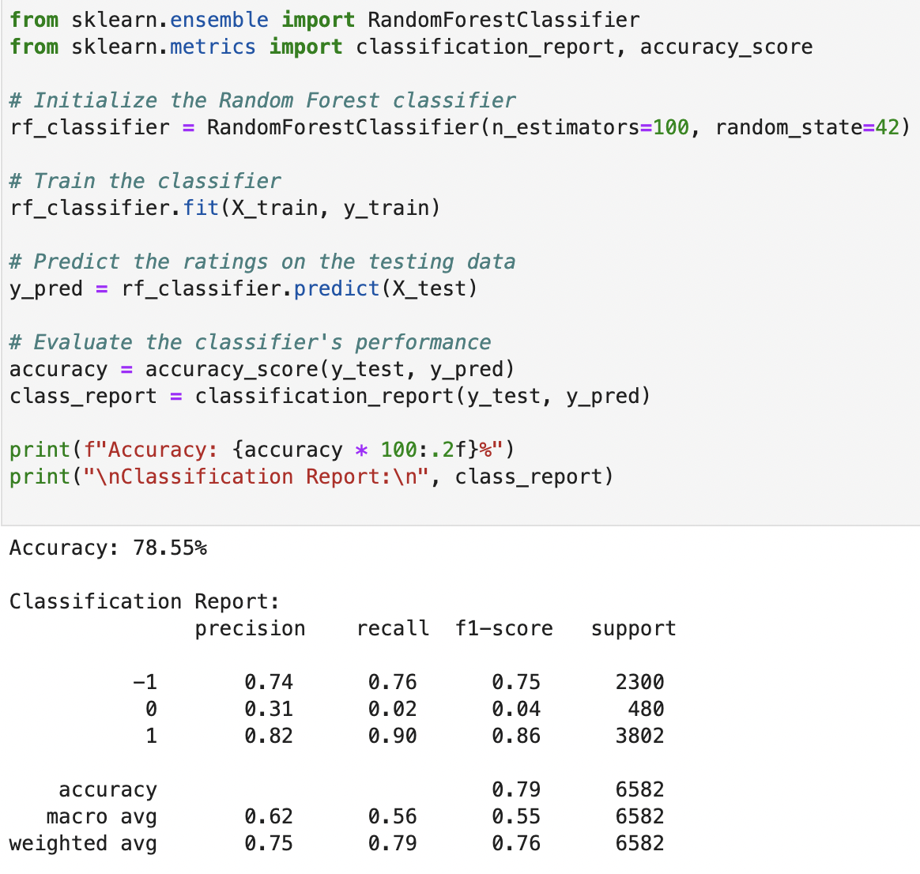

* The Random Forest classifier achieved an accuracy of **78.55%** on testing data. The classifier performed best in identifying reviews with a rating of "1", with a precision of 0.82 and recall of 0.90. However, it struggled to classify reviews with a rating of "0", achieving only a 0.31 precision and 0.02 recall. The overall weighted average precision and recall across all classes were 0.75 and 0.79, respectively.

**Random Forest Model with SMOTE:**

* SMOTE (Synthetic Minority Over-sampling Technique) is applied to address class imbalance. It generates synthetic samples in the feature space to create a balanced dataset.
* For our dataset , there are fewer reviews with a certain rating "0", SMOTE will generate additional synthetic reviews of that rating to balance out the number of instances across all classes.
* A Random Forest classifier is initialized with 100 trees.
* The classifier is trained using the SMOTE-augmented data. The trained model predicts the ratings on the test data.
* The classifier's performance is evaluated using accuracy and a detailed classification report that includes precision, recall, and F1-score.

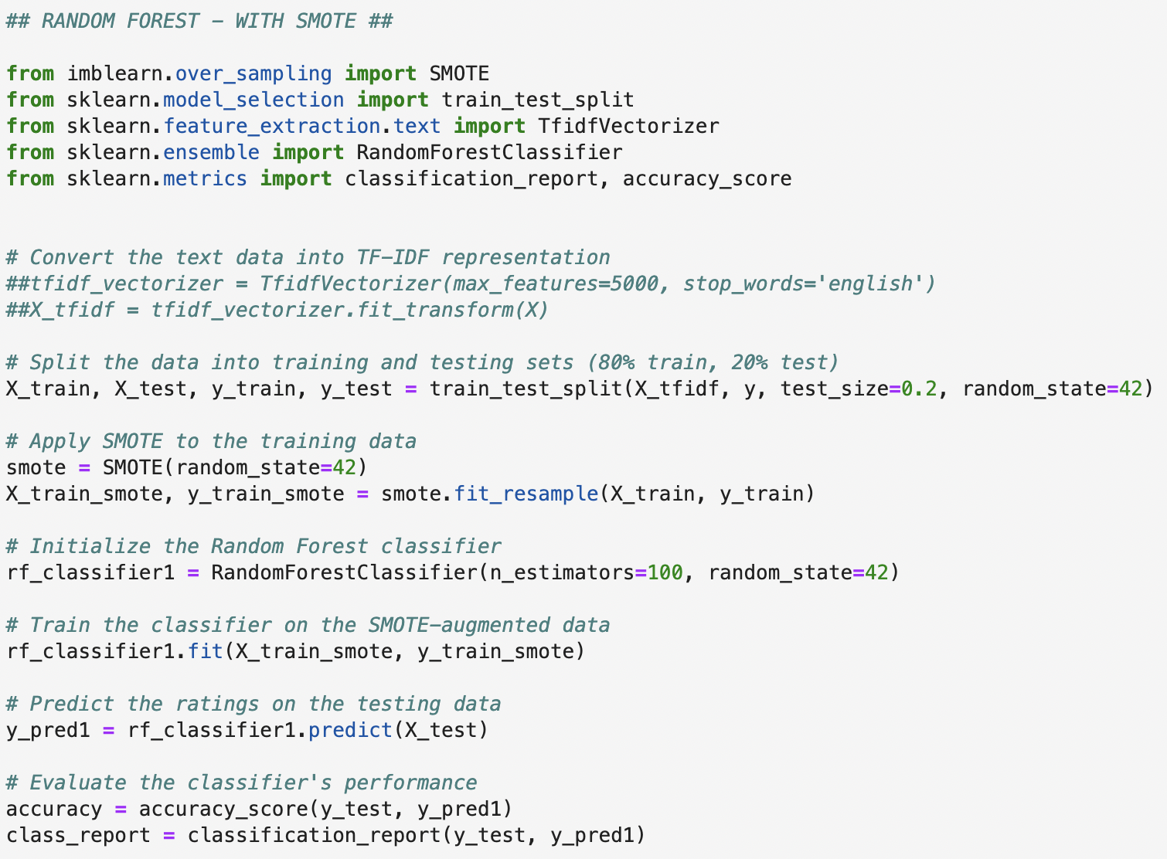

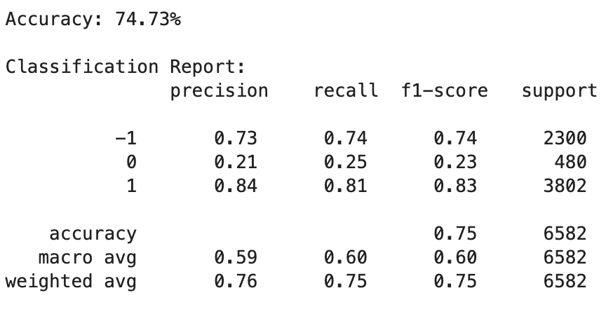

The Random Forest classifier, trained on SMOTE-augmented data, achieved an accuracy of 74.73%. The model performed well for ratings "-1" (F1-score: 0.74) and "1" (F1-score: 0.83), but had challenges with rating "0" (F1-score: 0.23). The overall accuracy is decent, but there's room for improvement, especially in correctly classifying and predicting the "0" ratings.

**Gradient Boosting Model :**

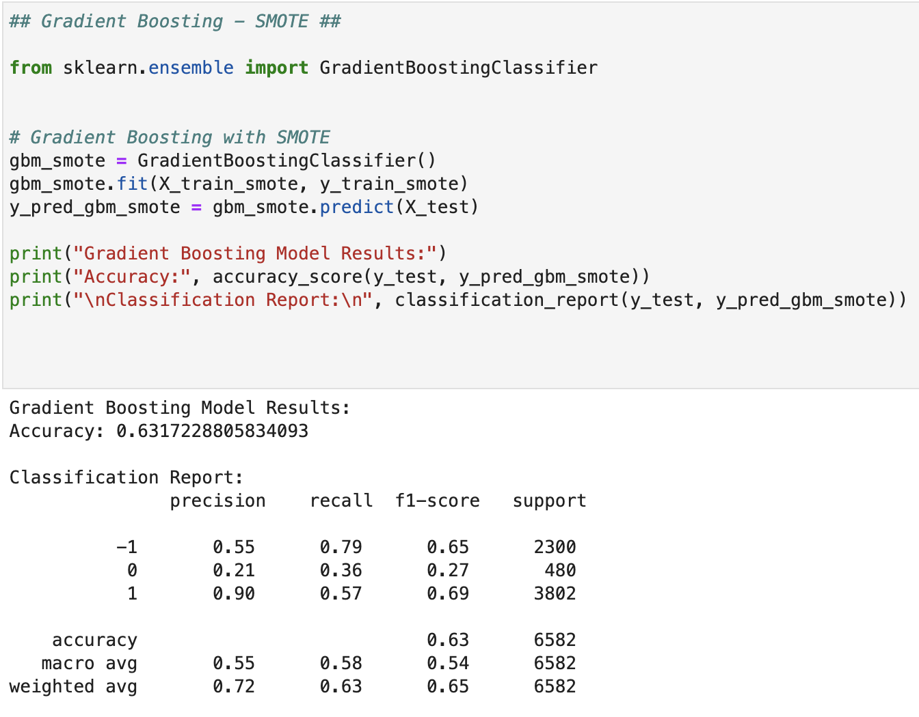

The Gradient Boosting classifier, when trained on SMOTE-augmented data, yielded an accuracy of 63.17%. The classifier showed a notable performance for rating "1" with a high precision of 0.90, but a lower F1-score of 0.69 due to decreased recall. For rating "-1", it achieved an F1-score of 0.65, and for rating "0", it secured an F1-score of 0.27.

This indicates that the model had a balanced performance for "-1" and "1" ratings but faced challenges in accurately predicting the "0" rating.

**SVM Model:**

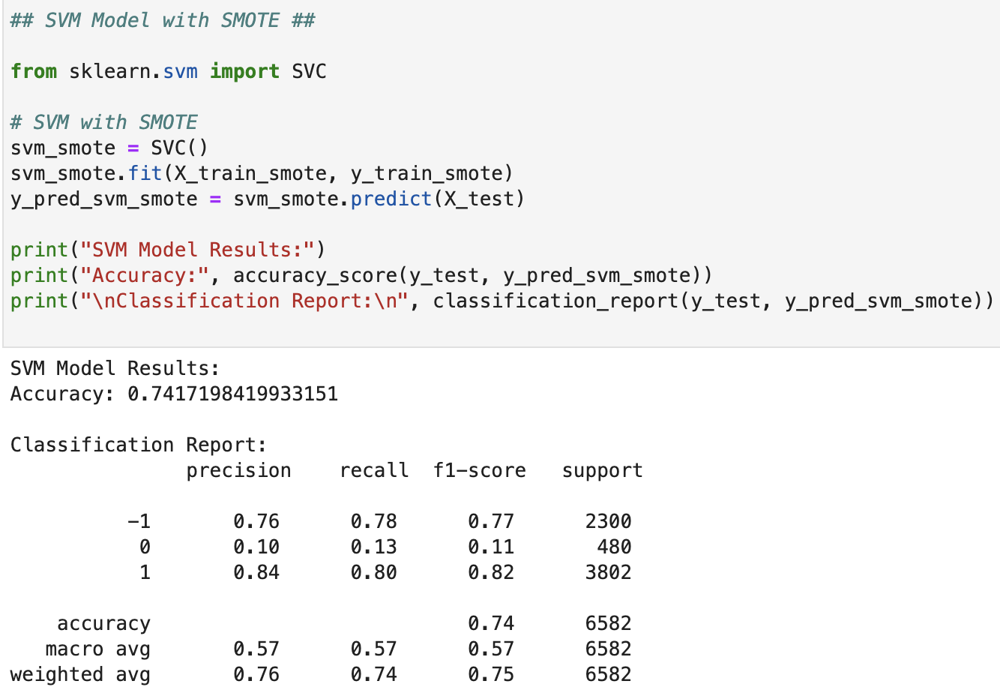

The Support Vector Machine (SVM) classifier, when trained with SMOTE-augmented data, achieved an accuracy of 74.17%. Specifically:

- For the rating "-1", the model displayed an F1-score of 0.77, with precision and recall being approximately equal at 0.76 and 0.78, respectively.

- The model had difficulty with the rating "0", as evidenced by an F1-score of only 0.11. The precision for this rating was low at 0.10, while the recall was slightly higher at 0.13

- For the rating "1", the SVM model performed well with an F1-score of 0.82, driven by a strong precision of 0.84 and a recall of 0.80.

- The overall macro average F1-score was 0.57, and the weighted average F1-score stood at 0.75, indicating the model's strength in classifying "-1" and "1" ratings but challenges with the "0" rating.

**MODEL COMPARISON**

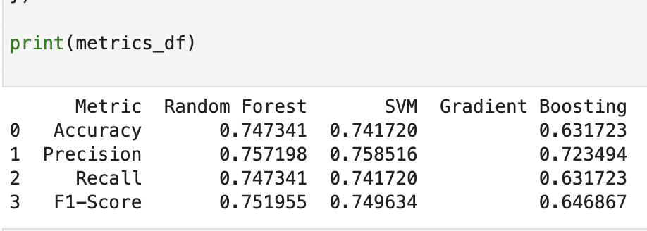

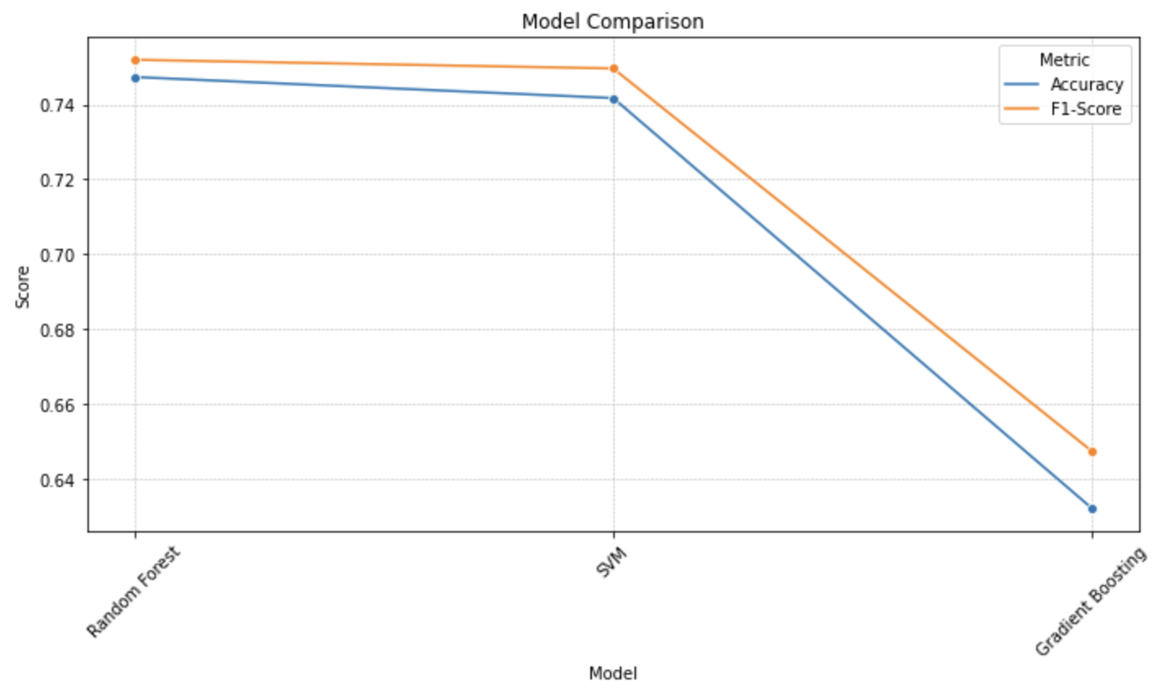

**Accuracy:**

The Random Forest model achieved the highest accuracy at 74.73%.

SVM closely followed with 74.17%.

Gradient Boosting had a notably lower accuracy at 63.17%.

**Precision:**

SVM had the highest precision at 75.85%.

Random Forest was very close at 75.72%.

Gradient Boosting, again, lagged with 72.35%.

**Recall:**

Much like accuracy, Random Forest led with 74.73%, followed by SVM at 74.17% and Gradient Boosting at 63.17%.

**F1-Score:**

Random Forest and SVM had very comparable F1-Scores, 75.20% and 74.96%, respectively.

Gradient Boosting's F1-Score was lower at 64.69%.

Overall, the Random Forest and SVM models had comparable performance, with Random Forest slightly edging out in most metrics. Gradient Boosting trailed in all metrics.

**Predicting Synthetic Reviews**

Lastly , we will try predicting some synthetic reviews using our trained Random forest classifier to predict the sentiments. For this, the review text is first converted into its TF-IDF representation using the tfidf_vectorizer.transform method. Then, it is fed to the classifier for prediction.

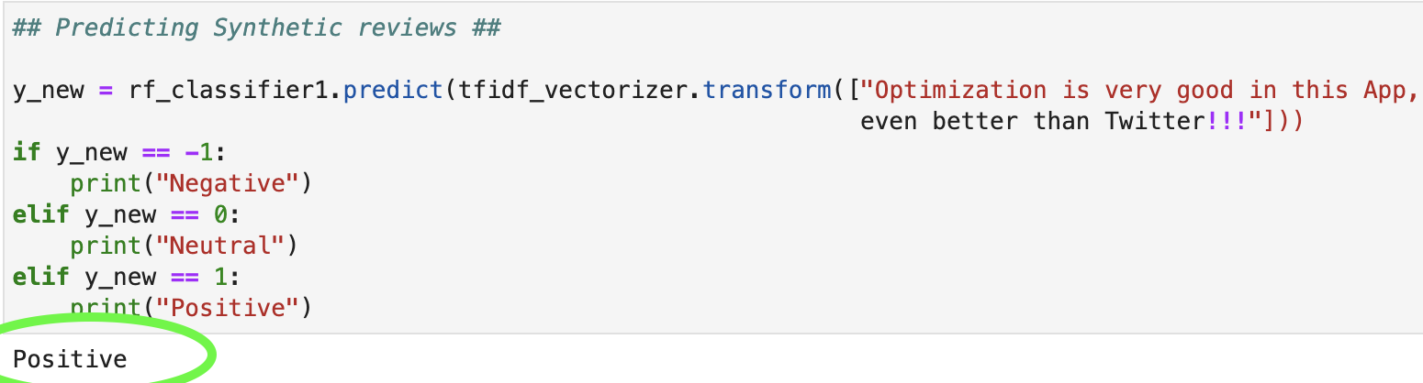

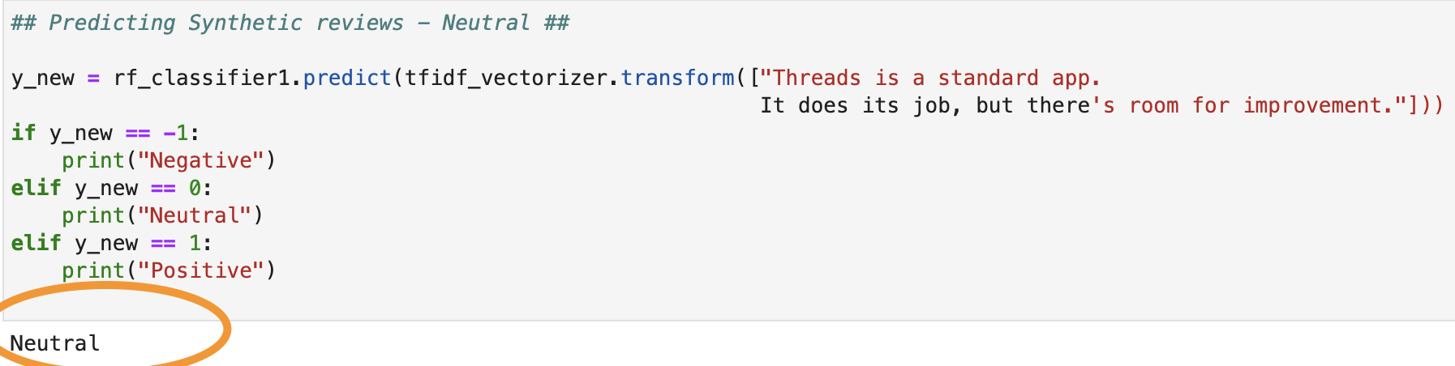

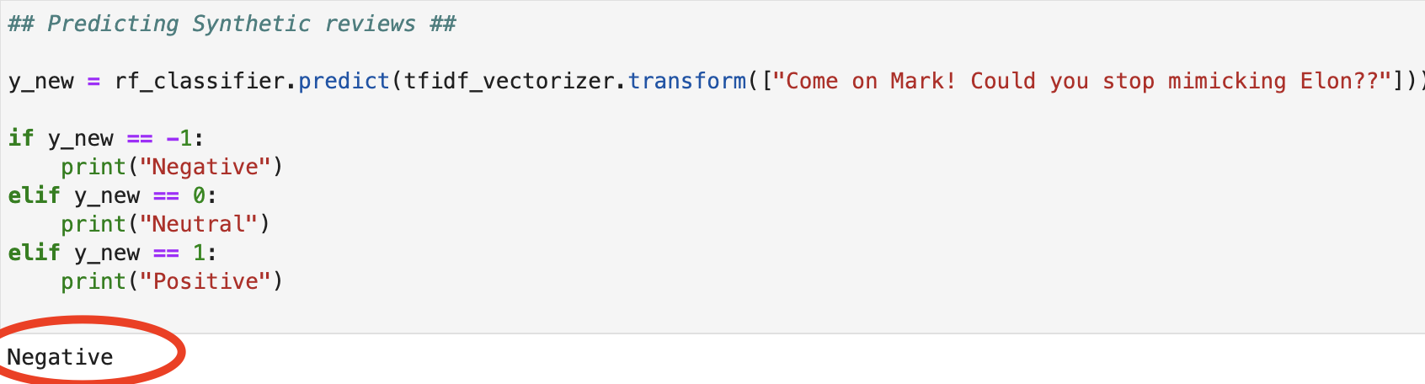

As seen in above results , our RF classifier is able to correctly predict all the sentiment of the reviews

**CONCLUSION**

In this analysis, we embarked on the journey of sentiment analysis by processing textual reviews. Starting with the data cleaning phase, non-essential content was pruned, ensuring that the dataset was structured, noise-free, and ready for the next steps. We then proceeded with exploratory data analysis to get insights about the reviews and data distribution. We then utilized the TF-IDF vectorization technique to convert text reviews into numerical format, making them suitable for machine learning models.

Splitting the data revealed class imbalances, prompting the introduction of the SMOTE technique. SMOTE generated synthetic samples, ensuring a balanced training set which is crucial for unbiased classification.

Models including Random Forest, SVM, and Gradient Boosting, were trained both with and without SMOTE. Performance metrics, such as accuracy, precision, recall, and F1-score, were evaluated. The Random Forest and SVM models achieved comparable performance, with accuracies around 74%, while Gradient Boosting trailed with approximately 63% accuracy. Nevertheless, the results from precision, recall, and F1-score metrics highlighted the strengths and weaknesses of each model for different sentiment categories.

Lastly, the analysis concluded with a practical application: using the Random Forest classifier to predict the sentiment of a synthetic review, showcasing the model's capability to provide real-time insights.

**References**

1. https://www.kaggle.com/datasets/saloni1712/threads-an-instagram-app-reviews/data
2. <https://www.datacamp.com/tutorial/random-forests-classifier-python>
3. <https://towardsdatascience.com/master-machine-learning-random-forest-from-scratch-with-python-3efdd51b6d7a>
4. <https://northeastern.instructure.com/courses/160443/pages/lesson-4-3-gradient-boosting-introduction?module_item_id=9500073>

**Appendix**

|  |
| --- |
| import numpy as np  import pandas as pd  import matplotlib.pyplot as plt  import seaborn as sns  #Loading data#  df = pd.read_csv('/Users/bhagyashrikadam/Documents/NEU_ASSIGNMENTS/ALY6020/Final Project/threads_reviews.csv')  df.shape  print(df.dtypes)  df.head(10)  **## PART1 ##**  **## Data Cleaning ##**  **# Checking the number of missing values ##**  **missing_values = df.isnull().sum()**  **print(missing_values)**  # Checking for duplicate rows  duplicate_rows = df.duplicated().sum()  duplicate_rows  df = df.drop_duplicates()  # Get the minimum and maximum review dates  min_date = df['review_date'].min()  max_date = df['review_date'].max()  print(f"Minimum Review Date: {min_date}")  print(f"Maximum Review Date: {max_date}")  # Convert 'review_date' column to datetime format  df['review_date'] = pd.to_datetime(df['review_date'])  # Check data types  df.dtypes  # Separate the date and time from the 'review_date' column  df['review_date_new'] = df['review_date'].dt.date  df['review_time'] = df['review_date'].dt.time  # Display the first few rows to verify  df[['review_date', 'review_date_new', 'review_time']].head()  # Drop the original 'review_date' column  df = df.drop(columns=['review_date'])  df.head(2)  # Create a new 'day' column using the 'review_date' column  df['day'] = pd.to_datetime(df['review_date_new']).dt.day_name()  df.head(10)  # Check data types  df.dtypes  # Convert 'review_date_new' to datetime datatype  df['review_date_new'] = pd.to_datetime(df['review_date_new'])  # Convert 'review_time' to datetime and then extract the time component  df['review_time'] = pd.to_datetime(df['review_time'], format='%H:%M:%S').dt.time  # Create a new column 'hour' based on the 'review_time' column  def get_part_of_day(time):  if 5 <= time.hour < 12:  return 'morning'  elif 12 <= time.hour < 17:  return 'afternoon'  elif 17 <= time.hour < 21:  return 'evening'  else:  return 'night'  df['hour'] = df['review_time'].apply(get_part_of_day)  ## EDA ##  # Bar-plot for different ratings #  import plotly.express as px  # Interactive bar plot for distribution of ratings  rating_counts = df['rating'].value_counts().reset_index()  rating_counts.columns = ['Rating', 'Count']  fig_bar_ratings = px.bar(rating_counts, x='Rating', y='Count', title='Distribution of Ratings',  labels={'Rating': 'Rating', 'Count': 'Number of Reviews'},  color='Rating', color_continuous_scale='Viridis')  fig_bar_ratings.show()  # Pie-chart distribution of ratings  rating_distribution = df['rating'].value_counts().reset_index()  rating_distribution.columns = ['Rating', 'Count']  # Create an interactive pie chart for rating distribution  fig_pie_rating = px.pie(rating_distribution, names='Rating', values='Count', title='Distribution of Ratings',  hole=0.3, labels={'Rating':'Rating'}, color_discrete_sequence=px.colors.qualitative.Pastel)  fig_pie_rating.update_traces(textinfo='percent+label')  fig_pie_rating.show()  # Interactive donut-chart for distribution of review sources  source_distribution = df['source'].value_counts().reset_index()  source_distribution.columns = ['Source', 'Count']  # Create an interactive pie chart  fig_pie_source = px.pie(source_distribution, names='Source', values='Count', title='Distribution of Review Sources',  hole=0.3, labels={'Source':'Review Source'}, color_discrete_sequence=px.colors.qualitative.Set2)  fig_pie_source.update_traces(textinfo='percent+label')  fig_pie_source.show()  # Interactive donut-chart for distribution of review sources per Ratings  import plotly.express as px  # Grouping by source and rating to get the count of each rating for both sources  grouped_data = df.groupby(['source', 'rating']).size().reset_index(name='count')  # Creating pie chart for each source  figs = []  for source_name in grouped_data['source'].unique():  source_data = grouped_data[grouped_data['source'] == source_name]  fig = px.pie(source_data, names='rating', values='count', title=f'Ratings Distribution for {source_name}', hole=0.3)  fig.update_traces(textinfo='percent+label')  figs.append(fig)  # Displaying the pie charts  for fig in figs:  fig.show()  import plotly.express as px  # Grouping by day and hour to get the count of reviews for each combination  grouped_data = df.groupby(['day', 'hour']).size().reset_index(name='count')  # Creating an interactive bar plot  fig = px.bar(grouped_data, x='day', y='count', color='hour',  title='Review Count by Day and Hour',  labels={'count': 'Review Count'},  color_discrete_sequence=["#B0E2FF", "#FF8247", "#FDE725", "#00008B"])  # Display the plot  fig.show()  # Daily reviews by review source #  daily_reviews_by_source = df.groupby([df['review_date_new'].dt.date, 'source']).size().reset_index()  daily_reviews_by_source.columns = ['Date', 'Source', 'Number of Reviews']  # Interactive time series plot for daily reviews by source  fig_daily_reviews_source = px.line(daily_reviews_by_source, x='Date', y='Number of Reviews', color='Source',  title='Daily Reviews by Source Over Time',  labels={'Number of Reviews': 'Number of Reviews', 'Date': 'Date'})  fig_daily_reviews_source.show()  !pip install -q wordcloud  from wordcloud import WordCloud  # Generate word cloud for review_description  text = ' '.join(df['review_description'])  wordcloud = WordCloud(background_color='white', width=800, height=400).generate(text)  # Plot the word cloud  plt.figure(figsize=(12, 6))  plt.imshow(wordcloud, interpolation='bilinear')  plt.axis('off')  plt.title('Word Cloud for Review Descriptions')  plt.show()  ## Top 30 words used in Reviews ##  from collections import Counter  import plotly.express as px  import string  # Simple tokenizer without using nltk  def simple_tokenizer(text):  # Convert to lower case and remove punctuation  text = text.lower().translate(str.maketrans('', '', string.punctuation))  # Split the text into words  words = text.split()  # Remove stopwords  stop_words = set(['i', 'me', 'my', 'myself', 'we', 'our', 'ours', 'ourselves', 'you', "you're", "you've", "you'll", "you'd", 'your', 'yours', 'yourself', 'yourselves', 'he', 'him', 'his', 'himself', 'she', "she's", 'her', 'hers', 'herself', 'it', "it's", 'its', 'itself', 'they', 'them', 'their', 'theirs', 'themselves', 'what', 'which', 'who', 'whom', 'this', 'that', "that'll", 'these', 'those', 'am', 'is', 'are', 'was', 'were', 'be', 'been', 'being', 'have', 'has', 'had', 'having', 'do', 'does', 'did', 'doing', 'a', 'an', 'the', 'and', 'but', 'if', 'or', 'because', 'as', 'until', 'while', 'of', 'at', 'by', 'for', 'with', 'about', 'against', 'between', 'into', 'through', 'during', 'before', 'after', 'above', 'below', 'to', 'from', 'up', 'down', 'in', 'out', 'on', 'off', 'over', 'under', 'again', 'further', 'then', 'once'])  words = [word for word in words if word not in stop_words]  return words  reviews = ' '.join(df['review_description'])  tokenized_reviews = simple_tokenizer(reviews)  word_freq = Counter(tokenized_reviews)  # Extracting the top 30 words and their counts  top_words = word_freq.most_common(30)  word_names = [word[0] for word in top_words]  word_values = [word[1] for word in top_words]  # Define a custom color palette  color_palette = px.colors.qualitative.Set1  # Creating an interactive horizontal bar plot with the custom color palette  fig = px.bar(x=word_values, y=word_names, orientation='h', title='Top 30 Most Common Words in Reviews', color=word_names, color_discrete_sequence=color_palette)  fig.show()  !pip install -q joypy  ## Ridge Chart - Review text length by Rating ##  import joypy  import matplotlib.pyplot as plt  # Assuming 'review_text' is the column containing the review descriptions  df['text_length'] = df['review_description'].str.len()  # Create the ridge plot with a larger size  fig, ax = joypy.joyplot(  df,  by='rating',  column='text_length',  figsize=(10, 5), # Adjusted size  title='Review Description Length by Rating',  colormap=plt.cm.viridis,  alpha=0.6,  overlap=0.5  )  # Set x-axis limits and custom tick marks  for axis in ax:  axis.set_xlim(0, 2000) # Adjusted x-axis limits  axis.set_xticks([0, 250, 500, 1000, 1500, 2000]) # Custom tick marks  plt.show()  #clubbing rating 1 and 2 as '-1' , 3 as '0' and 4,5 as '1'  df['rating'] = df['rating'].map({1:-1, 2:-1, 3:0, 4:1, 5:1})  # Getting the value counts  rating_counts = df['rating'].value_counts()  print(rating_counts)  # Visualizing the distribution using a bar plot  import seaborn as sns  import matplotlib.pyplot as plt  plt.figure(figsize=(8, 6))  sns.barplot(x=rating_counts.index, y=rating_counts.values, palette="pastel")  plt.title('Distribution of Clubbed Ratings')  plt.xlabel('Rating')  plt.ylabel('Count')  plt.show()  ## Text Pre-Processing ##  import re  # Define a basic list of stopwords  basic_stopwords = set([  "i", "me", "my", "myself", "we", "our", "ours", "ourselves", "you", "your", "yours", "yourself", "yourselves",  "he", "him", "his", "himself", "she", "her", "hers", "herself", "it", "its", "itself", "they", "them", "their",  "theirs", "themselves", "what", "which", "who", "whom", "this", "that", "these", "those", "am", "is", "are", "was",  "were", "be", "been", "being", "have", "has", "had", "having", "do", "does", "did", "doing", "a", "an", "the", "and",  "but", "if", "or", "because", "as", "until", "while", "of", "at", "by", "for", "with", "about", "against", "between",  "into", "through", "during", "before", "after", "above", "below", "to", "from", "up", "down", "in", "out", "on", "off",  "over", "under", "again", "further", "then", "once"  ])  # Define a function for text pre-processing  def preprocess_text_simple(text):  # Convert to lowercase  text = text.lower()  # Remove URLs  text = re.sub(r'http\S+|www\S+|https\S+', '', text, flags=re.MULTILINE)  # Remove emojis  text = text.encode('ascii', 'ignore').decode('ascii')  # Remove punctuation  text = re.sub(r'[^\w\s]', '', text)  # Tokenization  tokens = text.split()  # Remove stopwords  tokens = [token for token in tokens if token not in basic_stopwords]  return ' '.join(tokens)  # Apply the pre-processing function to the 'review_description' column  df['processed_description'] = df['review_description'].apply(preprocess_text_simple)  # Display the first few rows to verify  df[['review_description', 'processed_description']].head()  ## Top 20 Frequent words in Reviews ##  from collections import Counter  # Combine all the preprocessed reviews into a single string  all_reviews = ' '.join(df['processed_description'])  # Tokenize the combined string to get individual words  tokens = all_reviews.split()  # Count the frequency of each word  word_freq = Counter(tokens)  # Display the top 20 most frequent words  top_20_words = word_freq.most_common(20)  top_20_words  ## Horizontal Barplot - Top 20 Frequent words in Reviews ##  import plotly.graph_objects as go  # Create the bar plot  fig = go.Figure(data=[  go.Bar(x=word_values, y=word_names, orientation='h')  ])  # Update the layout settings  fig.update_layout(  title='Top 20 Most Frequent Words in Reviews',  xaxis_title='Frequency',  yaxis_title='Words',  yaxis=dict(autorange="reversed", tickfont=dict(size=10)),  margin=dict(l=150) # Adjust left margin to make sure all y-axis labels fit  )  fig.show()  ## Word Cloud for each of the ratings ##  from wordcloud import WordCloud  import matplotlib.pyplot as plt  # Function to generate and display word cloud  def generate_wordcloud(data, title):  wordcloud = WordCloud(width=800, height=400, background_color='white').generate(data)  plt.figure(figsize=(10, 6))  plt.imshow(wordcloud, interpolation='bilinear')  plt.title(title)  plt.axis('off')  plt.show()  # Filter and generate word cloud for rating -1  negative_reviews = ' '.join(df[df['rating'] == -1]['processed_description'])  generate_wordcloud(negative_reviews, 'Word Cloud for Rating -1')  # Filter and generate word cloud for rating 0  neutral_reviews = ' '.join(df[df['rating'] == 0]['processed_description'])  generate_wordcloud(neutral_reviews, 'Word Cloud for Rating 0')  # Filter and generate word cloud for rating 1  positive_reviews = ' '.join(df[df['rating'] == 1]['processed_description'])  generate_wordcloud(positive_reviews, 'Word Cloud for Rating 1')  ## Top 20 Bigrams ##  from sklearn.feature_extraction.text import CountVectorizer  # Function to get top n-grams  def get_top_ngrams(corpus, ngram_range, top_n):  vec = CountVectorizer(ngram_range=ngram_range).fit(corpus)  bag_of_words = vec.transform(corpus)  sum_words = bag_of_words.sum(axis=0)  words_freq = [(word, sum_words[0, idx]) for word, idx in vec.vocabulary_.items()]  words_freq = sorted(words_freq, key=lambda x: x[1], reverse=True)  return words_freq[:top_n]  # Get top 20 bigrams  top_bigrams = get_top_ngrams(df['processed_description'], ngram_range=(2, 2), top_n=20)  # Extracting the bigram names and their values for plotting  bigram_names = [bigram[0] for bigram in top_bigrams]  bigram_values = [bigram[1] for bigram in top_bigrams]  # Using plotly express to create the bar plot  fig_bigrams = px.bar(x=bigram_values, y=bigram_names, orientation='h', title='Top 20 Bigrams in Reviews', labels={'x': 'Frequency', 'y': 'Bigrams'})  fig_bigrams.show()  # Get top 20 trigrams  top_trigrams = get_top_ngrams(df['processed_description'], ngram_range=(3, 3), top_n=20)  # Extracting the trigram names and their values for plotting  trigram_names = [trigram[0] for trigram in top_trigrams]  trigram_values = [trigram[1] for trigram in top_trigrams]  # Using plotly express to create the bar plot  fig_trigrams = px.bar(x=trigram_values, y=trigram_names, orientation='h', title='Top 20 Trigrams in Reviews', labels={'x': 'Frequency', 'y': 'Trigrams'})  fig_trigrams.show() |
| ## TF-IDF Vectorization ##  from sklearn.feature_extraction.text import TfidfVectorizer  # Initialize a TF-IDF Vectorizer  tfidf_vectorizer = TfidfVectorizer(max_df=0.85, max_features=20, stop_words='english')  # Fit and transform the processed descriptions to get the TF-IDF values  tfidf_values = tfidf_vectorizer.fit_transform(df['processed_description'])  # Extract the feature names and their corresponding TF-IDF scores  tfidf_scores = sorted(list(zip(tfidf_vectorizer.get_feature_names_out(), tfidf_values.sum(axis=0).getA1())), key=lambda x: x[1], reverse=True)  # Extracting the word names and their tf-idf scores for plotting  tfidf_words = [word[0] for word in tfidf_scores]  tfidf_scores_values = [word[1] for word in tfidf_scores]  # Using plotly express to create the bar plot  fig_tfidf = px.bar(x=tfidf_scores_values, y=tfidf_words, orientation='h', title='Top Words based on TF-IDF Scores')  fig_tfidf.show()  ## RANDOM FOREST ##  from sklearn.model_selection import train_test_split  from sklearn.feature_extraction.text import TfidfVectorizer  from imblearn.over_sampling import SMOTE  # Splitting the data into features (X) and target (y)  X = df['review_description']  y = df['rating']  # Convert the text data into TF-IDF representation  tfidf_vectorizer = TfidfVectorizer(max_features=5000, stop_words='english')  X_tfidf = tfidf_vectorizer.fit_transform(X)  # Split the data into training and testing sets (80% train, 20% test)  X_train, X_test, y_train, y_test = train_test_split(X_tfidf, y, test_size=0.2, random_state=42)  X_train.shape, X_test.shape  from sklearn.ensemble import RandomForestClassifier  from sklearn.metrics import classification_report, accuracy_score  # Initialize the Random Forest classifier  rf_classifier = RandomForestClassifier(n_estimators=100, random_state=42)  # Train the classifier  rf_classifier.fit(X_train, y_train)  # Predict the ratings on the testing data  y_pred = rf_classifier.predict(X_test)  # Evaluate the classifier's performance  accuracy = accuracy_score(y_test, y_pred)  class_report = classification_report(y_test, y_pred)  print(f"Accuracy: {accuracy * 100:.2f}%")  print("\nClassification Report:\n", class_report)  ## RANDOM FOREST - WITH SMOTE ##  from imblearn.over_sampling import SMOTE  from sklearn.model_selection import train_test_split  from sklearn.feature_extraction.text import TfidfVectorizer  from sklearn.ensemble import RandomForestClassifier  from sklearn.metrics import classification_report, accuracy_score  # Convert the text data into TF-IDF representation  ##tfidf_vectorizer = TfidfVectorizer(max_features=5000, stop_words='english')  ##X_tfidf = tfidf_vectorizer.fit_transform(X)  # Split the data into training and testing sets (80% train, 20% test)  X_train, X_test, y_train, y_test = train_test_split(X_tfidf, y, test_size=0.2, random_state=42)  # Apply SMOTE to the training data  smote = SMOTE(random_state=42)  X_train_smote, y_train_smote = smote.fit_resample(X_train, y_train)  # Initialize the Random Forest classifier  rf_classifier1 = RandomForestClassifier(n_estimators=100, random_state=42)  # Train the classifier on the SMOTE-augmented data  rf_classifier1.fit(X_train_smote, y_train_smote)  # Predict the ratings on the testing data  y_pred1 = rf_classifier1.predict(X_test)  # Evaluate the classifier's performance  accuracy = accuracy_score(y_test, y_pred1)  class_report = classification_report(y_test, y_pred1)  print(f"Accuracy: {accuracy * 100:.2f}%")  print("\nClassification Report:\n", class_report)  ## Gradient B  oosting - SMOTE ##  from sklearn.ensemble import GradientBoostingClassifier  # Gradient Boosting with SMOTE  gbm_smote = GradientBoostingClassifier()  gbm_smote.fit(X_train_smote, y_train_smote)  y_pred_gbm_smote = gbm_smote.predict(X_test)  print("Gradient Boosting Model Results:")  print("Accuracy:", accuracy_score(y_test, y_pred_gbm_smote))  print("\nClassification Report:\n", classification_report(y_test, y_pred_gbm_smote))  ## SVM Model with SMOTE ##  from sklearn.svm import SVC  # SVM with SMOTE  svm_smote = SVC()  svm_smote.fit(X_train_smote, y_train_smote)  y_pred_svm_smote = svm_smote.predict(X_test)  print("SVM Model Results:")  print("Accuracy:", accuracy_score(y_test, y_pred_svm_smote))  print("\nClassification Report:\n", classification_report(y_test, y_pred_svm_smote))  ## MODEL COMPARISON ##  from sklearn.metrics import accuracy_score, precision_score, recall_score, f1_score  import pandas as pd  # Define a function to compute metrics  def compute_metrics(y_true, y_pred):  accuracy = accuracy_score(y_true, y_pred)  precision = precision_score(y_true, y_pred, average='weighted')  recall = recall_score(y_true, y_pred, average='weighted')  f1 = f1_score(y_true, y_pred, average='weighted')  return accuracy, precision, recall, f1  # Compute metrics for each model  rf_metrics = compute_metrics(y_test, y_pred1)  svm_metrics = compute_metrics(y_test, y_pred_svm_smote)  gbm_metrics = compute_metrics(y_test, y_pred_gbm_smote)  # Tabulate results  metrics_df = pd.DataFrame({  'Metric': ['Accuracy', 'Precision', 'Recall', 'F1-Score'],  'Random Forest': rf_metrics,  'SVM': svm_metrics,  'Gradient Boosting': gbm_metrics  })  print(metrics_df)  import matplotlib.pyplot as plt  import seaborn as sns  # Data  data = {  'Metric': ['Accuracy', 'Precision', 'Recall', 'F1-Score'],  'Random Forest': [0.747341, 0.757198, 0.747341, 0.751955],  'SVM': [0.741720, 0.758516, 0.741720, 0.749634],  'Gradient Boosting': [0.632027, 0.723015, 0.632027, 0.647293]  }  metrics_df = pd.DataFrame(data)  # Filter for only Accuracy and F1-Score  filtered_df = metrics_df[metrics_df['Metric'].isin(['Accuracy', 'F1-Score'])]  # Melt the dataframe for plotting  melted_df = pd.melt(filtered_df, id_vars='Metric', value_vars=['Random Forest', 'SVM', 'Gradient Boosting'])  # Plot  plt.figure(figsize=(10, 6))  sns.lineplot(data=melted_df, x='variable', y='value', hue='Metric', marker='o')  plt.title('Model Comparison')  plt.xlabel('Model')  plt.ylabel('Score')  plt.xticks(rotation=45)  plt.grid(True, which='both', linestyle='--', linewidth=0.5)  plt.tight_layout()  plt.show()  ## Predicting Synthetic reviews - Positive ##  y_new = rf_classifier1.predict(tfidf_vectorizer.transform(["Optimization is very good in this App, even better than Twitter!!!"]))  if y_new == -1:  print("Negative")  elif y_new == 0:  print("Neutral")  elif y_new == 1:  print("Positive")  ## Predicting Synthetic reviews - Negative ##  y_new = rf_classifier1.predict(tfidf_vectorizer.transform(["Come on Mark! Could you stop mimicking Elon??"]))  if y_new == -1:  print("Negative")  elif y_new == 0:  print("Neutral")  elif y_new == 1:  print("Positive")  ## Predicting Synthetic reviews - Neutral ##  y_new = rf_classifier1.predict(tfidf_vectorizer.transform(["Threads is a standard app.It does its job, but there's room for improvement."]))  if y_new == -1:  print("Negative")  elif y_new == 0:  print("Neutral")  elif y_new == 1:  print("Positive") |